**DAILY ONLINE ACTIVITIES SUMMARY**

|  |  |  |  |  |
| --- | --- | --- | --- | --- |
| **Date:** | 14/07/2020 | **Name:** | JASLINE SHARON TAURO | |
| **Sem & Sec** | 4th sem,  A Section | **USN:** | 4AL18CS029 | |
| **Online Test Summary** | | | | |
| **Subject** | N/A | | | |
| **Max. Marks** | N/A | **Score** | N/A | |
| **Certification Course Summary** | | | | |
| **Course** | Programming for Everybody (Getting started with python) | | | |
| **Certificate Provider** | Coursera | **Duration:** | | 3 hrs |
| **Coding Challenges** | | | | |
| **Problem Statement:**  Write a java program to check for balanced parenthesis. | | | | |
| **Status:** | | Executed | | |
| **Uploaded the report in GitHub** | | YES | | |
| **If yes Repository name** | | <https://github.com/jaslinesharontauro/JAVA_Prgms> | | |
| **Uploaded the report in slack** | | YES | | |

**CERTIFICATION COURSE DETAILS:**

Today I continued the course “Programming for Everybody (Getting started with python)” by Coursera. Today I learnt about how to use python playground and tool text editor. I have completed week2 portion of this course.

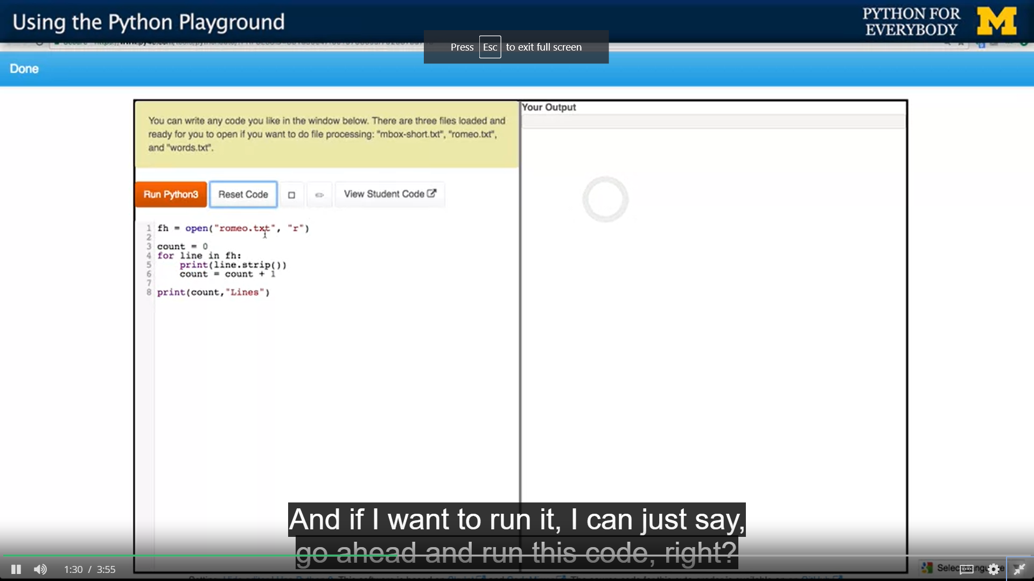

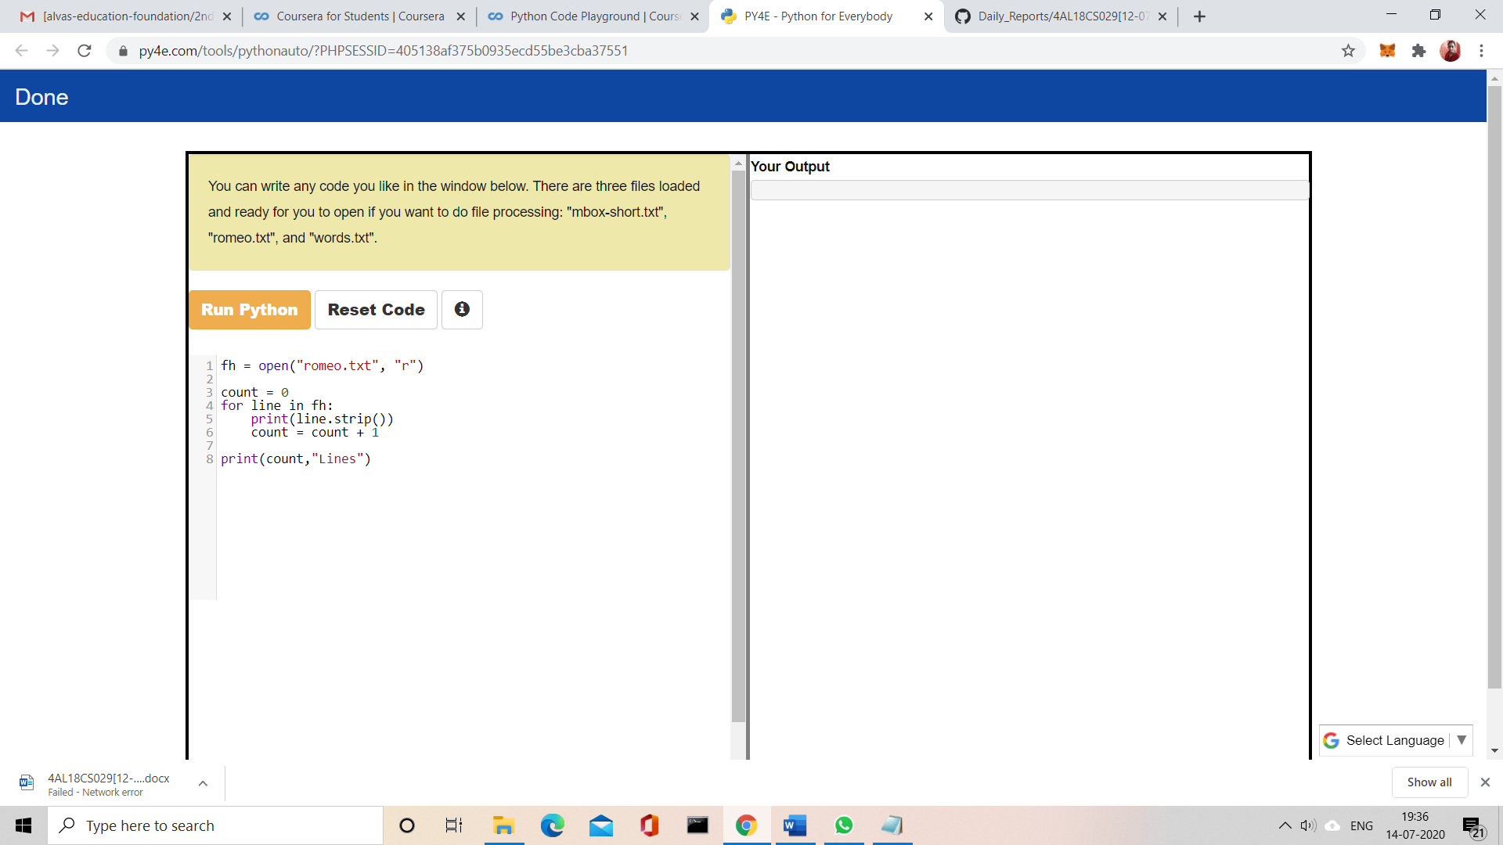

CODING CHALLENGES:

Problem Statement:

Write a java program to check for balanced parenthesis.

Given an expression string exp. Examine whether the pairs and the orders of “{“,”}”,”(“,”)”,”[“,”]” are correct in exp.  
For example, the program should print 'balanced' for exp = “[()]{}{()()}” and 'not balanced' for exp = “[(])”

Input:  
Input consists of a string of expression, in a separate line.

Output:  
Print 'balanced' without quotes if the pair of parenthesis is balanced else print 'not balanced' in a separate line.

Example:  
Input:  
{([])}  
()  
([]

Output:  
balanced  
balanced  
not balanced

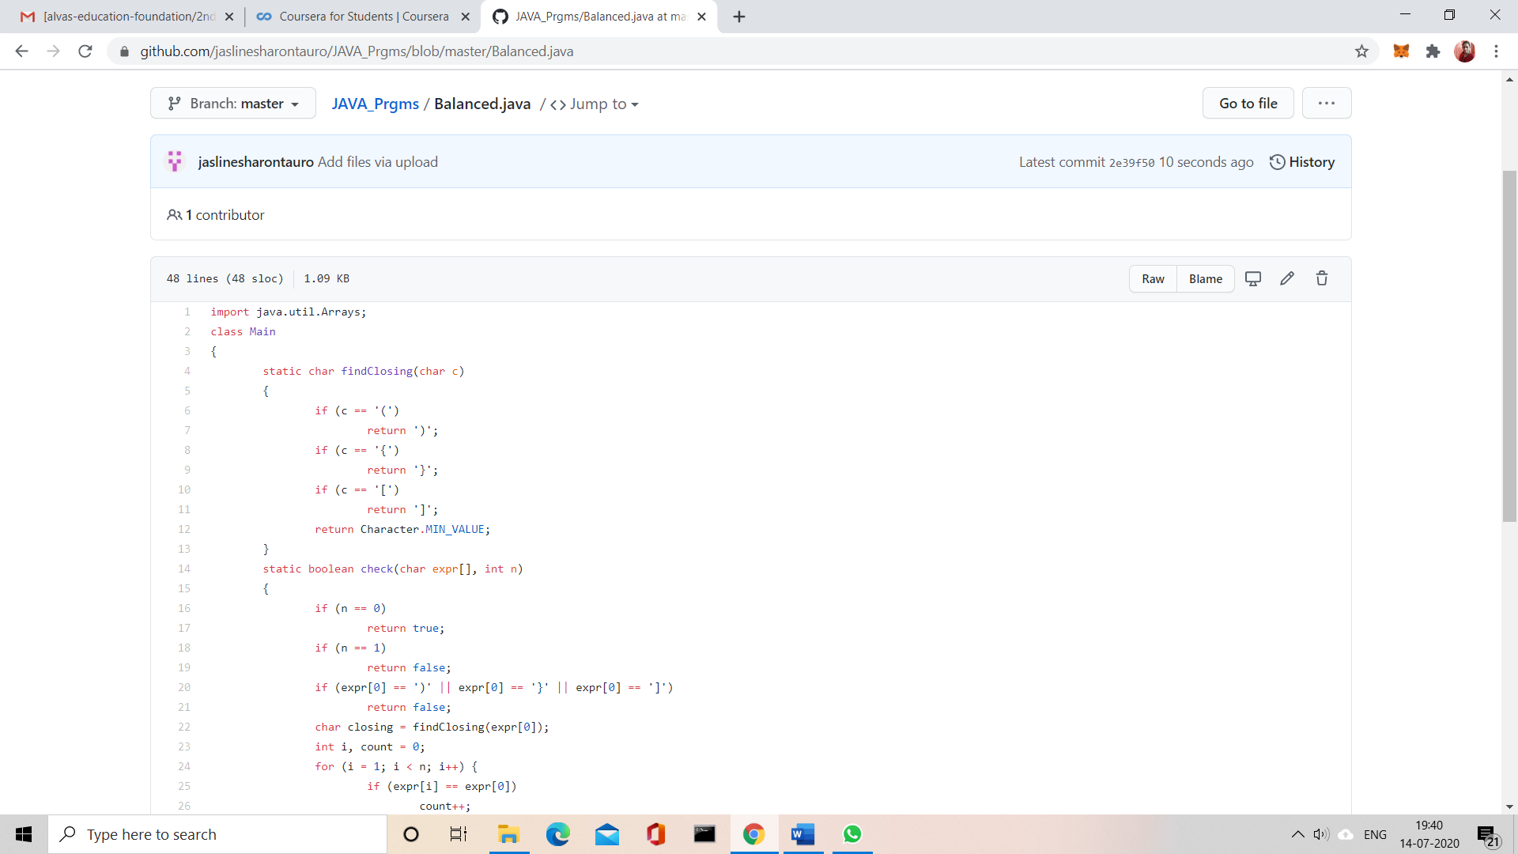

Solution uploaded in GitHub